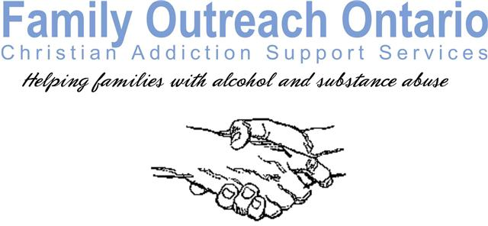
Application for Membership

Family Outreach Ontario Christian Addiction Support Services is a faith-based inter-denominational not-for-profit organization. Trusting in God we have provided a response to the very real problem of alcohol and drug addiction, having a special interest within the Christian community. We believe that chemical addiction is a complex disease that has physical, mental and spiritual components. We also believe that help is readily available for those who seek it. As an organization, we accept the challenge of walking alongside of those who are hurting, as many of us once were, to the best of our ability. With a spirit of love we strive to educate and support individuals struggling with addiction and their loved ones who are otherwise affected to fully recover and realize the full potential of the life God intends for them.

Confidentiality and anonymity of those who seek help is one of the cornerstones upon which our organization was founded. All members are bound by this principal to the best of their abilities.

We firmly believe that we cannot fix those who are hurting due to addiction. Our prayer is that God will use us to help bring hope to those He puts in our paths.

ACKNOWLEDGEMENT: I have read the above statements regarding Family Outreach Ontario Christian Addiction Support Services and agree to abide by them to the best of my ability.

Name: ______________________________________ Date: __________________________
Print

______________________________________
Sign

Address: _____________________________________________________________________________

______________________________________________________________________________________________

Phone: __________________________ Email: _____________________________________

Church Affiliation (optional): _____________________________________________________________

Please mail completed form to address below or scan & email to info@familyoutreachontario.com
Mail to: Family Outreach Ontario, 1292 Glancaster Rd., Ancaster, ON L9G 3L1

